Indexes - How to Set, Reset, and Use Indexes

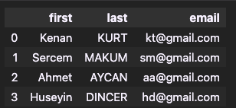
Here there is somethimg looks like a column without a name. These are indexes. Indexes are the range of numbers that basically an integer identifier for the rows. They are usually uniqe but somethimes they are not. Pandas doesn’t make them forces to be unique but they are generally uniqe values.

SET_INDEX ( “ column_name “ , inplace ) FUNCTION
df.set_index('email')

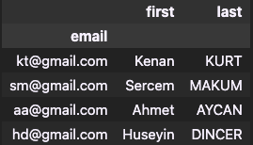we see email columns as index but this cange is not permenant. When we write df again we can see out dataframe still the same.
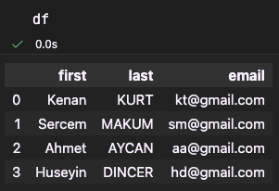

If we want to change index permanentliy we can use
df.set_index(‘column_name’ , inplace = True )
df.set_index('email' , inplace = True)

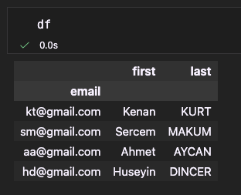
Our dataframe is changed now. As we can see here when we write df email column is index from now on. We modified dataframe.
df.index

Index(['kt@gmail.com', 'sm@gmail.com', 'aa@gmail.com', 'hd@gmail.com'], dtype='str', name='email')
Okey why this is useful ?
E mail adresses as index gives us nice unique identifier for our row and these indexes are the labels for these rows so before we just use the default range index but now we can find a specific row by passing that label.

For example: we can see information about kt@gmail.com easily:
df.loc['kt@gmail.com']

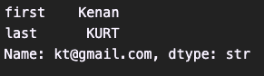

df.loc['kt@gmail.com', 'last']

‘KURT’

After change the indexes if we use
df.loc[0]

we get error because we don’t have index with that name anymore.
But if we use iloc we can get the information :
df.iloc[0]

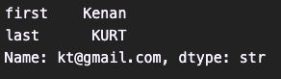
We used location instead of name.

RESET_INDEX FUNCTION
If we want to reset changes that we did :
df.reset_index(inplace = True)
df

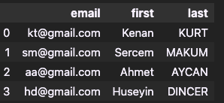

Now to get understand better we are gonna take a look big data set.
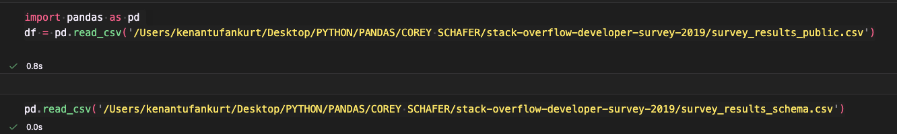
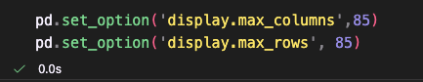
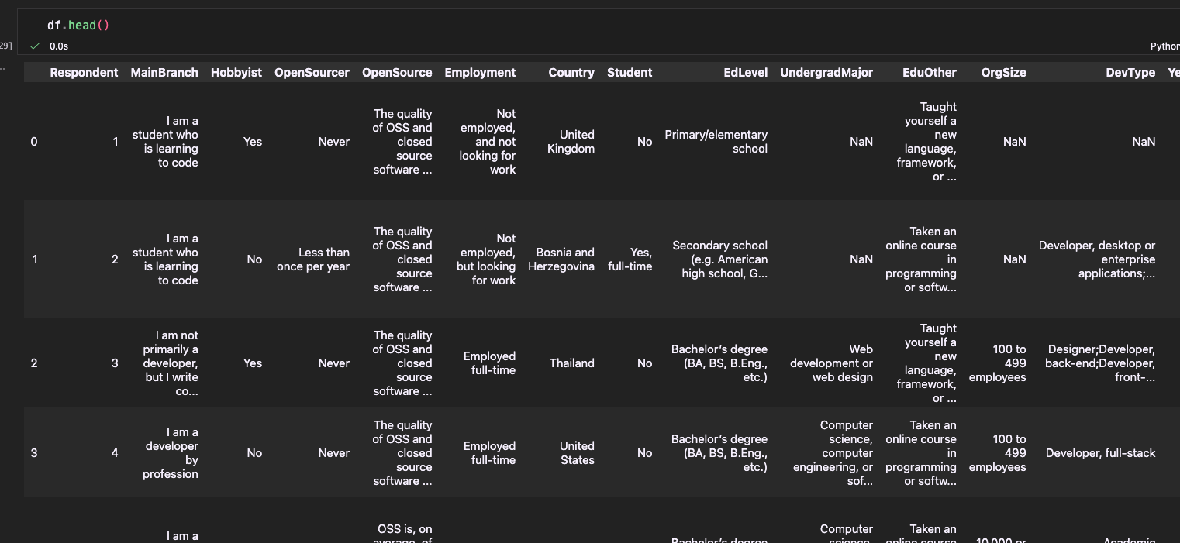
Here our big data we use normally default indexes. But here we already have respondent column is actually a unique ID . now we can clean a bit our dataframe and since respondent column has unique values we can use it as index.
We can set it by using csv file:
import pandas as pd
df = pd.read_csv('/Users/kenantufankurt/Desktop/PYTHON/PANDAS/COREY SCHAFER/stack-overflow-developer-survey-2019/survey_results_public.csv', index_col = 'Respondent')

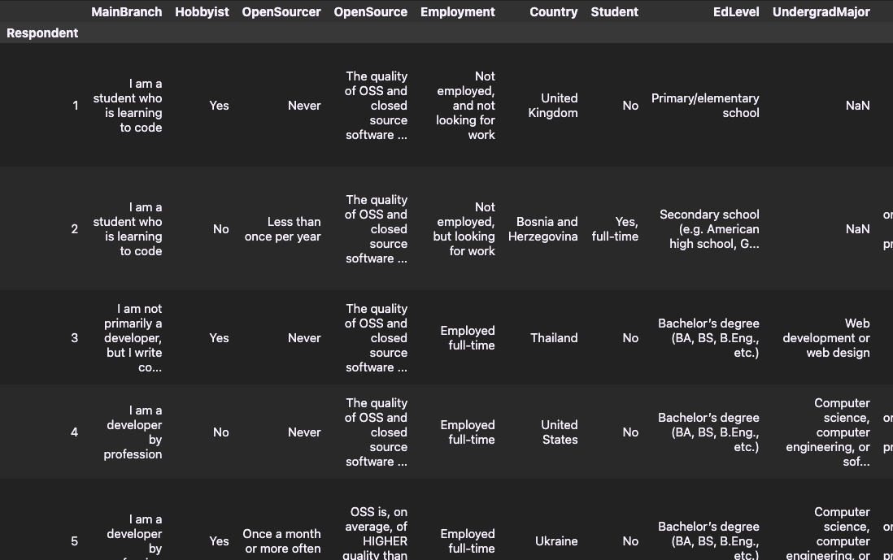
Now we set respondent column as index.

If we want to add end of the schema_df in a same way :
schema_df = pd.read_csv('/Users/kenantufankurt/Desktop/PYTHON/PANDAS/COREY SCHAFER/stack-overflow-developer-survey-2019/survey_results_schema.csv',index_col='Column')

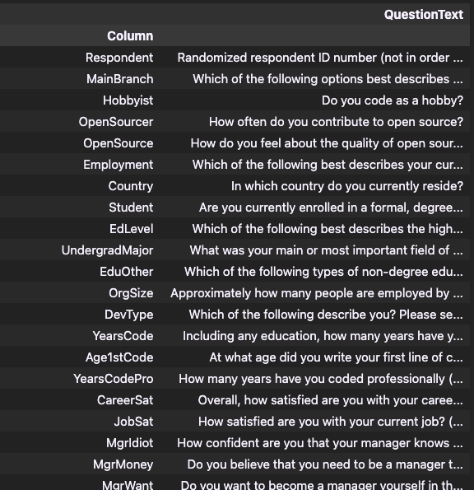
Now we can analyze both tables easier because here we made column index.
Our first table when we see hobbyist column we can see only yes or no answers but to check what is the question we should check df_schema table. Now we ca neasily check what the column meand because we made it index.
For example:
schema_df.loc['Hobbyist']

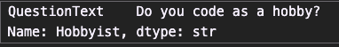
And when we check fort table :
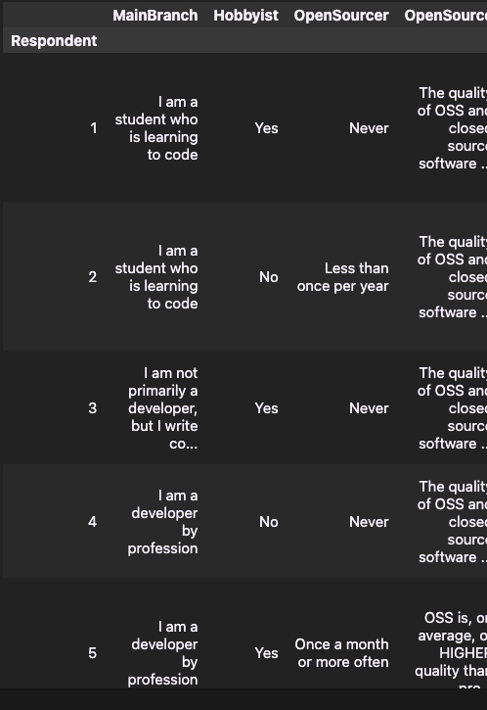
we know what the hobbyist column means from now on.
there is something another:
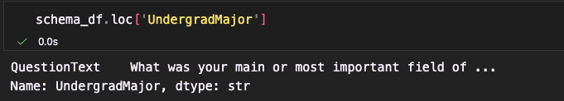
We cannot see the whole questiontext right ? so if we want to see the whole question text:
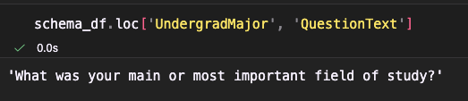
Now we can see whole question text belongs to UndergradMajor column.

SORT_INDEX(parameter) METHOD
If we want to sort indexes alphabetically:
schema_df.sort_index()

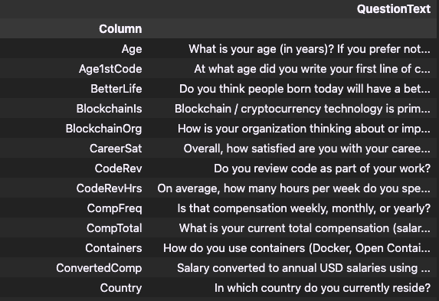

If we want to sort descendently:
schema_df.sort_index(ascending= False)

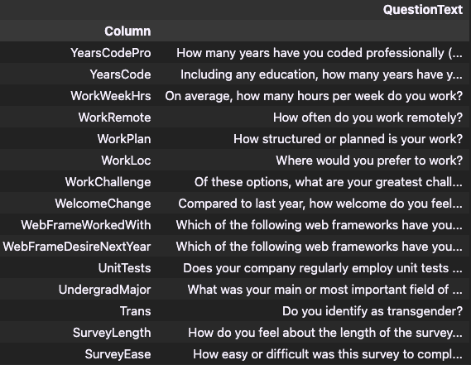
If we want to sort our data fram permenant and carry over into future selves, then we should set inplace = True.
schema_df.sort_index(inplace = True)
schema_df
now our data frame permenantly sorted.
